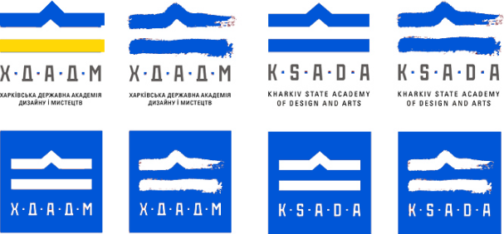

Ministry of Culture and Strategic Communications of Ukraine

National Academy of Arts of Ukraine

EASTERN REGIONAL SCIENTIFIC AND ARTISTIC CENTRE OF THE NAA OF UKRAINE

KHARKIV STATE ACADEMY OF DESIGN AND ARTS

National Academy of Visual Arts and Architecture

Lviv National Academy of Arts

Kharkiv Art Museum

**DEPARTMENT OF THEORY AND HISTORY OF ARTS**

**KHARKIV STATE ACADEMY OF DESIGN AND ARTS**

**17-18 April 2025**

**SECOND TARANUSHENKO’S READINGS**

**Dear colleagues!**

Invite you to take part in the International Scientific Conference of the Department of Theory and History of Arts of KSADA **SECOND TARANUSHENKO READINGS (2025).** The conference is dedicated to current issues in the history, theory, and art criticism of fine arts, as well as practical problems in the professional field of art studies.

The scientific conference will take place on April 17–18, 2025.  
The event is planned to be held **online.**

**Purpose:** To exchange opinions, ideas, and concepts to actualize research directions within the framework of the modern paradigm of art history, encompassing both classical and contemporary periods.

**TOPICS:**

* Kharkiv Art School: Traditions and Innovations
* Ukrainian Studies in Art History and Theory
* Contemporary Dimensions of World Art and Art Studies

**REGULATIONS:** Speech (with a presentation) up to 10 minutes, discussion – 5 minutes.

The working languages of the conference: Ukrainian, English.

**TERMS OF PARTICIPATION**

Researchers, art professionals, educators, postgraduate and doctoral students are invited to participate in the conference.

To participate, please complete the application form (see Appendix), which includes the title of the topic, a biographical note, and other relevant information, and send it to: [**taranushenko.chytannya.2025@gmail.com**](mailto:taranushenko.chytannya.2025@gmail.com)

The deadline for submitting applications and theses is **April 1, 2025**.

Participation in the conference is **free of charge.**

The Zoom platform link will be announced additionally.

Participant registration will take place during the connection to online sessions.

The conference program and participant certificates will be provided in electronic format.

**Theses** will be published in the conference proceedings (online format).

**Requirements for theses formatting:**

* **Total text volume:** 1–4 pages.
* **Required:** Title of the presentation, author's full name.
* **Main text:** Without references or bibliography, no hyphenation, no illustrations.
* **Format:** Word file, Times New Roman, 14 pt, line spacing 1.5.

***Sample Conference Abstract Format***

**Viktoria NAIDENKO**

Candidate of Arts (PhD),  
Senior Lecturer at the Department of Art Theory and History  
Kharkiv State Academy of Design and Arts

**“APPLE IN LEAVES” AS A CREATIVE AND PEDAGOGICAL CONCEPT OF VITALIY LENCHYN**

Text text text text text text text text text text text text text text text text text text text text text text text text text text text text text text text text text text text text text text text text text text text text text text text text text text.

The coordinators reserve the right to make editorial adjustments to the abstracts.

The electronic collection of abstracts will be published on the official KSADA website (Conference Materials): <https://www.new.ksada.org/naukovo-doslidna-diyalnist/naukovo-mysteczki-vydannya/materialy-naukovyh-konferenczij/>

For additional information, please contact:

[taranushenko.chytannya.2025@gmail.com](mailto:taranushenko.chytannya.2025@gmail.com)

**Coordinators:**

Chechyk Valentyna +38 (050) 40-37-519 (Telegram, Viber)

NAIDENKO Victoria +38 (050) 90-33-093 (Telegram, Viber)

**Sincerely,**

**Organizing Committee**

**Vladyslav KUTATELADZE** – Deputy Rector for Scientific  
and Research work of KSADA, Candidate of Arts and Sciences of design (PhD), Associate Professor.

**Ludmyla Sokolyuk** – Corresponding Member of the National Academy of Arts of Ukraine, Doctor of Study of Art, Professor, Professor of the Department of the Theory and History of Arts KSADA.

**Valentyna Chechyk** – Candidate of Arts (PhD), Associate Professor.

**Liudmyla MELNYCHUK** – Candidate of Arts (PhD), Associate Professor.

**Andrii KORNEV** – Candidate of Arts (PhD).

**Victoria NAIDENKO** – Head of the Department of Theory and History of Art, Candidate of Arts (PhD).